1. Introduction
Arduino is an open-source electronics platform based on easy-to-use hardware and software. This project demonstrates the basic use of digital input and digital output pins of an Arduino Uno by controlling an LED using push buttons. It is an ideal beginner-level project to understand breadboard wiring, resistors, and Arduino pin configuration.

2. Project Overview
The project consists of an Arduino Uno connected to a breadboard containing push buttons and an LED. The push buttons act as input devices, while the LED acts as an output device. The Arduino reads the button inputs and controls the LED based on the programmed logic. When a button is pressed, the LED turns ON or OFF accordingly.

3. Objectives
- To understand Arduino digital input and output pins
- To learn how to interface push buttons with Arduino
- To control an LED using external inputs
- To practice basic breadboard wiring and circuit design

4. Block Diagram
+-------------+ +-------------+ +---------+
| Push Button | ----> | Arduino UNO | ----> | LED |
+-------------+ +-------------+ +---------+

Explanation:
- Push buttons provide input signals
- Arduino processes the input signals
- LED displays the output result

5. Components Required
Component | Quantity
Arduino Uno | 1
Breadboard | 1
LED | 1
Push Buttons | 2
Resistor (220Ω–330Ω for LED) | 1
Resistor (10kΩ for buttons) | 2
Jumper Wires | As required
USB Cable | 1

6. Wiring Diagram Description

LED Connection
- LED Anode → Arduino digital pin D13 (through a 220Ω resistor)
- LED Cathode → Arduino GND

Push Button Connection
- One terminal of each push button → 5V
- Other terminal → Arduino digital pin (D2 or D3)
- A 10kΩ pull-down resistor connects each input pin to GND

Power Supply
- Arduino 5V → Breadboard positive rail
- Arduino GND → Breadboard negative rail

7. Pin Diagram
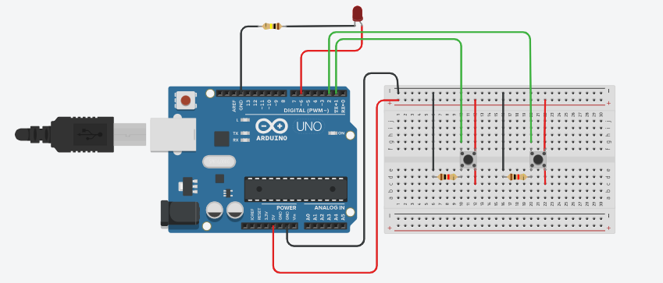
Arduino Pin | Connected Component
D2 | Push Button 1
D3 | Push Button 2
D13 | LED
5V | Breadboard + rail
GND | Breadboard – rail

8. Working Principle
- When a push button is pressed, a HIGH signal is sent to the Arduino input pin.
- The Arduino reads the input using the digitalRead() function.
- Based on the logic written in the program, the Arduino sets the LED pin HIGH or LOW using the digitalWrite() function.
- The LED turns ON or OFF accordingly.

9. Applications
- Learning Arduino basics
- Button-controlled electronic devices
- Home automation prototypes
- Embedded system training and education

10. Simulation Link
Tinkercad Project Link:
https://www.tinkercad.com/things/49MiqIIDYeZ-bodacious-albar-migelo?sharecode=f3k9jo61wu2UdfY9ERjQ-hMoFSCDCLVB4YxrHilOvlc

